#### **LIBRARY MANAGEMENT SYSTEM**

DBMS PROJECT

Submitted by

B Rohith kumar

RA1911003010940

Ladi Sailesh kumar

RA1911003010943

**Library mangament system:**

The Library Management System is gaining  more importance as the number of its users are increasing rapidly.

The transactions like login, register, add , search, delete, issue are provided. The Library Management System stores the details like name, address, ID number , Date Of Birth of members working in the library and users who come to library. The details of books like book name, book number, subject to which it belongs , author, edition, year of publication , the total  number of books that are present in the library etc are also stored.

Tables:

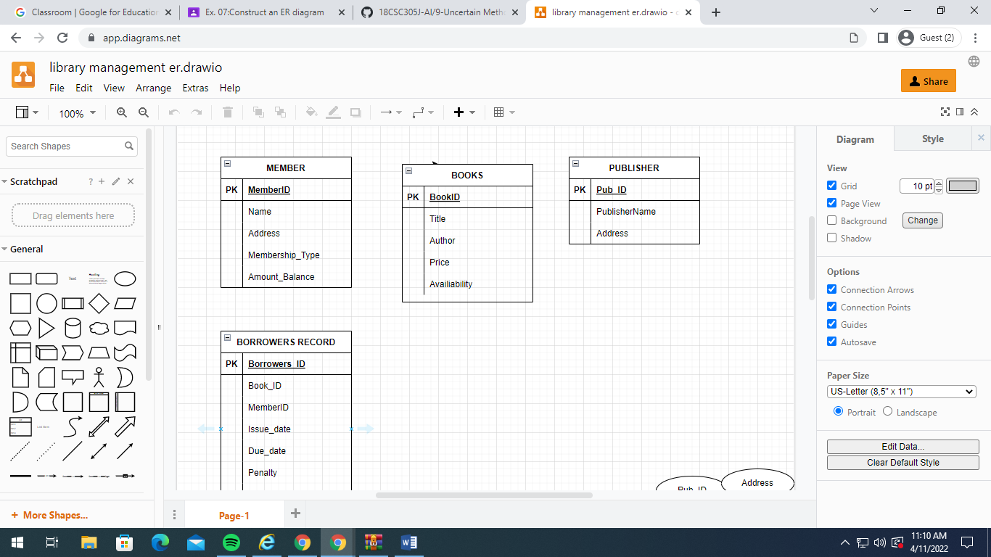

_Er daigram:

